

**DEPARTMENT OF MATHEMATICS**

**PROJECT RECORD**

**ON**

**A TRAGEDY OF FLIGHT**

**ACTIVITY: A COMPREHENSIVE CRASH ANALYSIS**

* **DATA ANALYTICS WITH TABLEAU**

**TAMILNADU SKILL DEVELOPMENT CORPORATION, GOVERNMENT OF TAMILNADU,**

* **NAAN MUDHALVAN PROGRAM**
* **Submitted**
* **By**

1. **SABARI PRIYA**
2. **JAMIUN NISHA**
3. **PRIYA LAKSHMI**
4. **SHIVANI**

**(III BSC MATHEMATICS)**

**CERTIFICATE**

THIS IS TO CERTIFY THAT THE PROJECT IS TITLED **A TRAGEDY OF FLIGHT: A COMPREHENSIVE CRASH ANALYSIS - DATA ANALYTICS WITH TABLEAU.**

THIS PROJECT IS SUBMITTED BY SABARIPRIYA, JAMIUNNISHA , PRIYA LAKSHMI , SHIVANI OF III B.SC MATHEMATICS, Dr MGR JANAKI COLLEGE OF ARTS AND SCIENCE FOR WOMEN, CHENNAI IN FULFILLMENT OF THE REQUIREMENTS FOR **TAMILNADU SKILL DEVELOPMENT CORPORATION, GOVERNMENT OF TAMILNADU,NAAN MUDHALVAN PROGRAM**. THIS PROJECT WAS AN AUTHENTIC WORK DONE BY HIM UNDER MY SUPERVISION AND GUIDANCE.

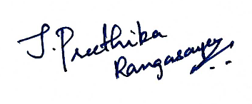 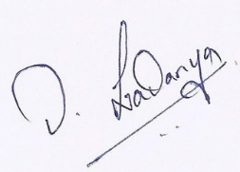

**PROJECT GUIDE HOD**

**TABLE OF CONTENTS**

|  |  |  |
| --- | --- | --- |
| **S.NO** | **CONTENTS** | **PAGE NO** |
| **1** | **INTRODUCTION** |  |
|  | 1.1 OVERVIEW | 3 |
|  | 1.2 PURPOSE | 3 |
| **2** | **PROBLEM DEFINITION & DESIGN THINKING** |  |
|  | 2.1 EMPATHY MAP | 4 |
|  | 2.2 IDEATION & BRAINSTORMING MAP | 4 |
| **3** | **RESULT** | 5 |
| **4** | **ADVANTAGES & DISADVANTAGES** | 14 |
| **5** | **CONCLUSION** | 14 |
| **6** | **FUTURE SCOPE** | 16 |
| **7** | **VIDEO** | 17 |

**INTRODUCTION**

* 1. **OVERVIEW**

Accidents in air transport are dominated by the failure of human factor failure, i.e. that of the aircrew. Despite of a positive development in the trend of accidents recorded since the beginning of the 21st century, the number of air accidents is still unsatisfactory. Consequently, it is of paramount importance to do everything that would contribute to substantial reduction of the human factor failure in air transportation. A system of models appears to be an important tool for overall understanding of the complexity of human factors, serving as starting-points to an analytical and classification research of the human factor. At the same time, these models enable qualified investigation and assessment of the causes of air and accidents, thereby preventing them from repeated occurrence. This assignment gathers data about these air crash.

* 1. **PURPOSE**

An incident is an event quite different form of an air accident related to the operation of the aircraft, which has and could have affected the safety of operation. It is understood mostly as a faulty action of persons or improper operation of airborne or ground-based equipment supporting air operation the consequences of which as a rule do not require premature termination of flight or performing non-routine emergency procedures.

Causes affecting the accident rate in air transportation can classified from various factors and points of view. The most general and probably the most transparent way of classification is dependence on human action or failure, technical and metrological factors. As far as the organizational or legislative shortcomings are concerned, they could also be instrumental in supporting the factors mentioned, mostly as a result of poor adherence to legislative procedures or mismanagement of air operation.

There is a range of causes to air accidents. In view of the fast development taking place in almost all the field of aviation, the occurrence of air accidents caused by aviation technology is reducing. The

Development however, is adding to the complexity of systems and raising the level of seriousness, all that to be managed by the aircrew. This very cause appears to be increasing in direct proportion to the accidents caused by human factors.

**PROBLEM DEFINITION AND DESIGN THINKING**

**2.1 EMPATHY MAP**



**2.2 IDEATION AND BRAINSTORMING MAP**

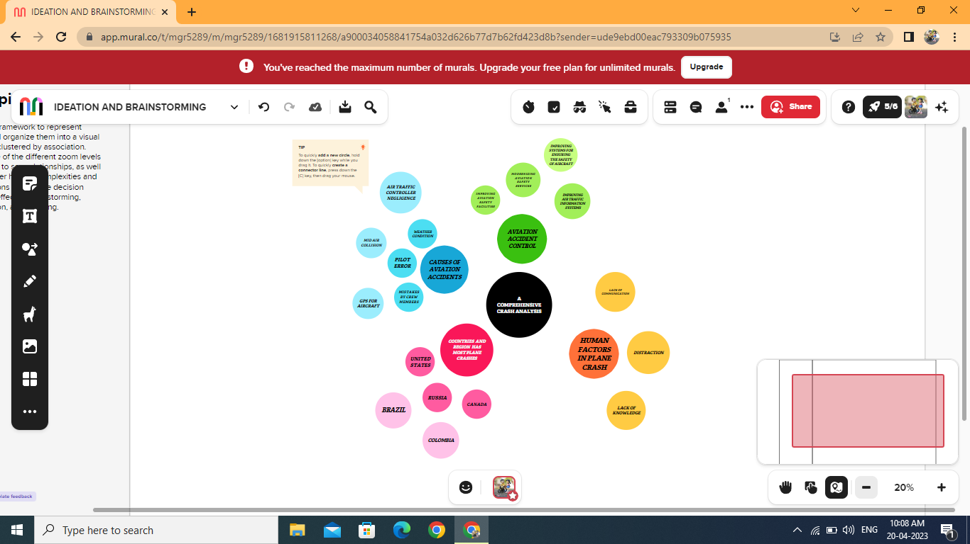

**RESULTS**

**3.1 DATA SOURCE**

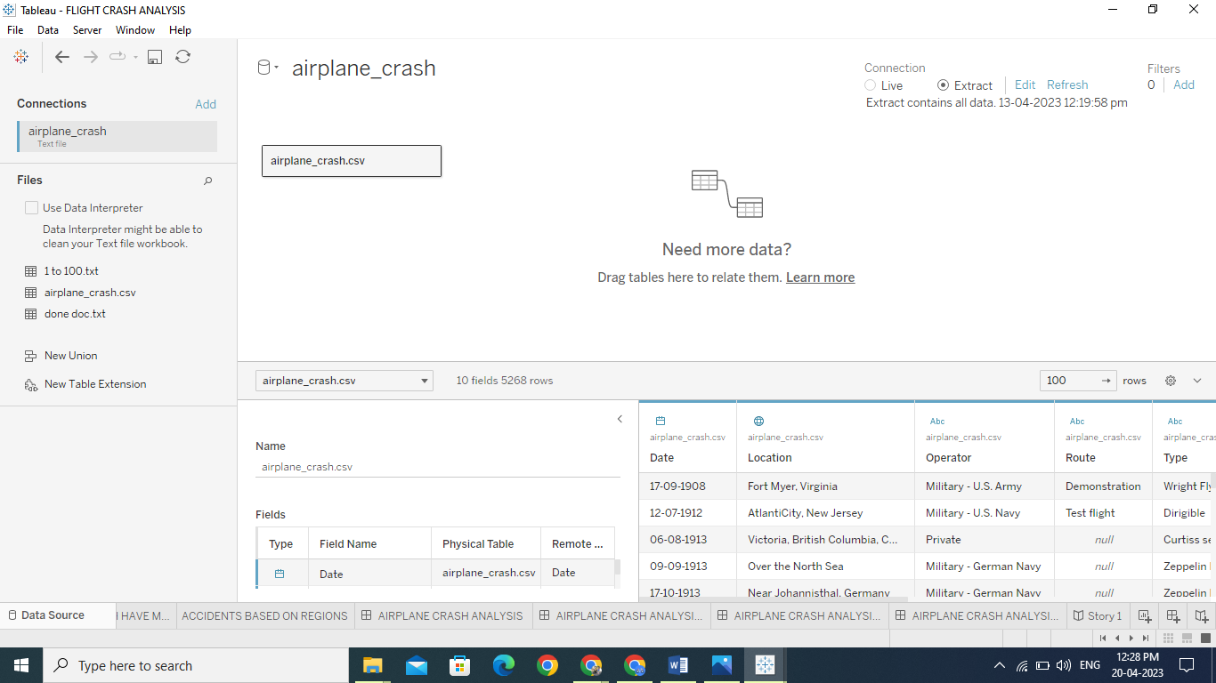

**3.2 COMPARING ABOARD VS FATALITIES VS GROUND**

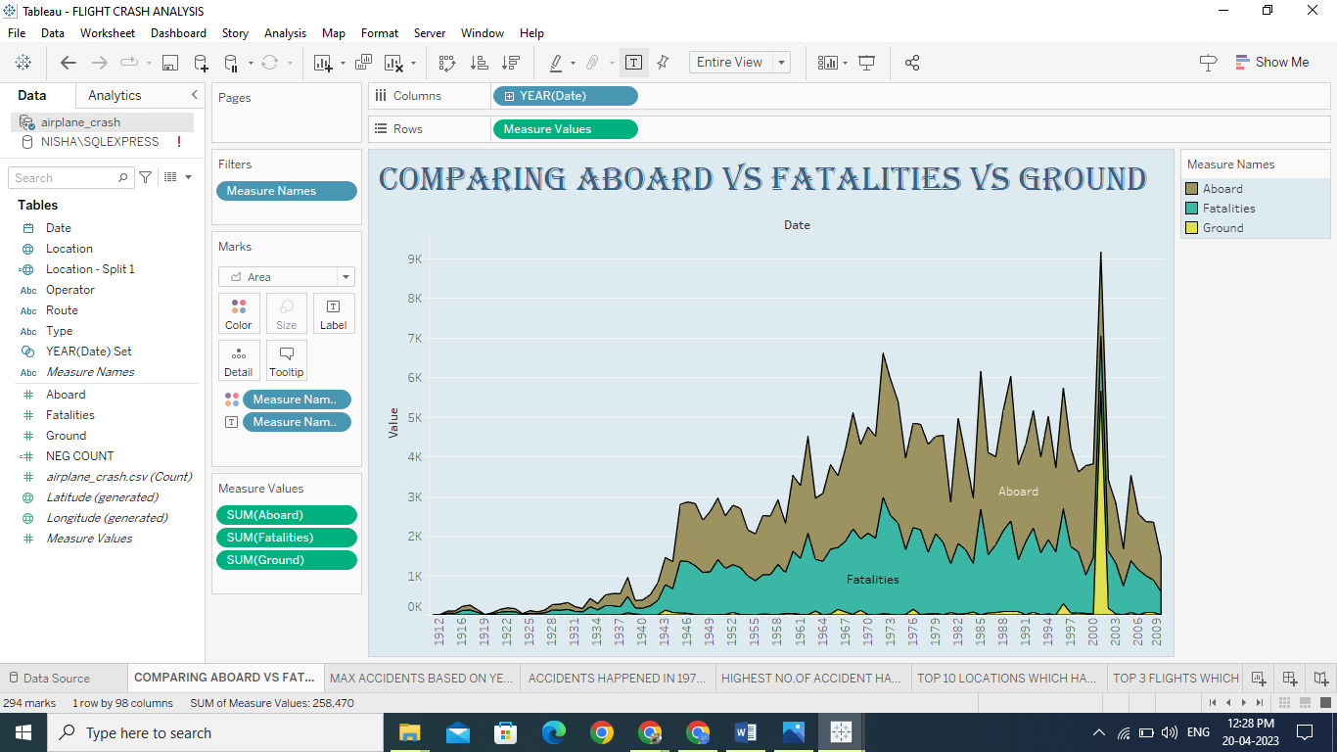

**3.3 MAX ACCIDENTS BASED ON YEARS**

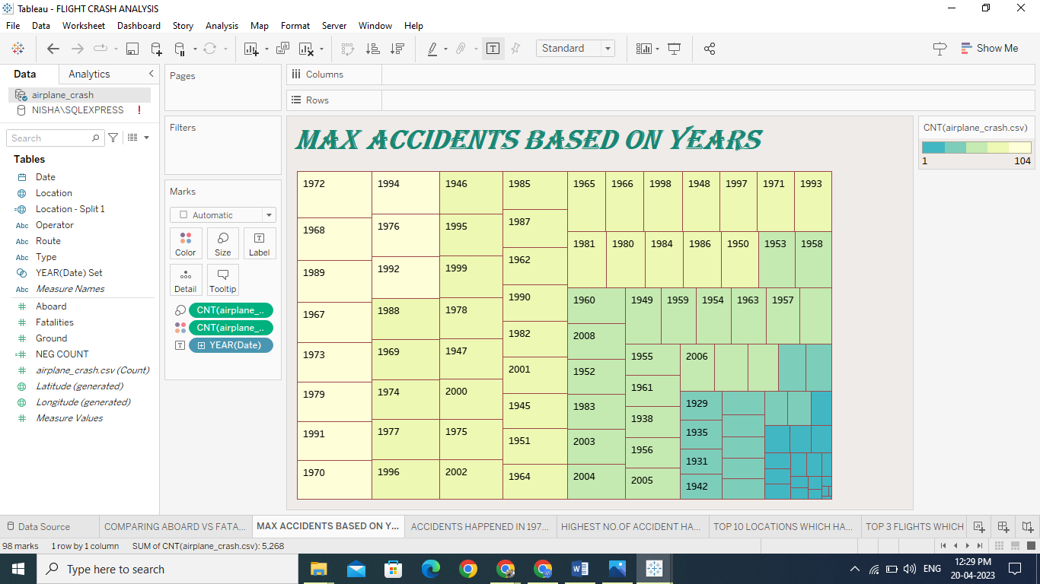

**3.4 ACCIDENTS HAPPENED IN 1972(MAX ACCIDENTS) BASED ON MONTHS**

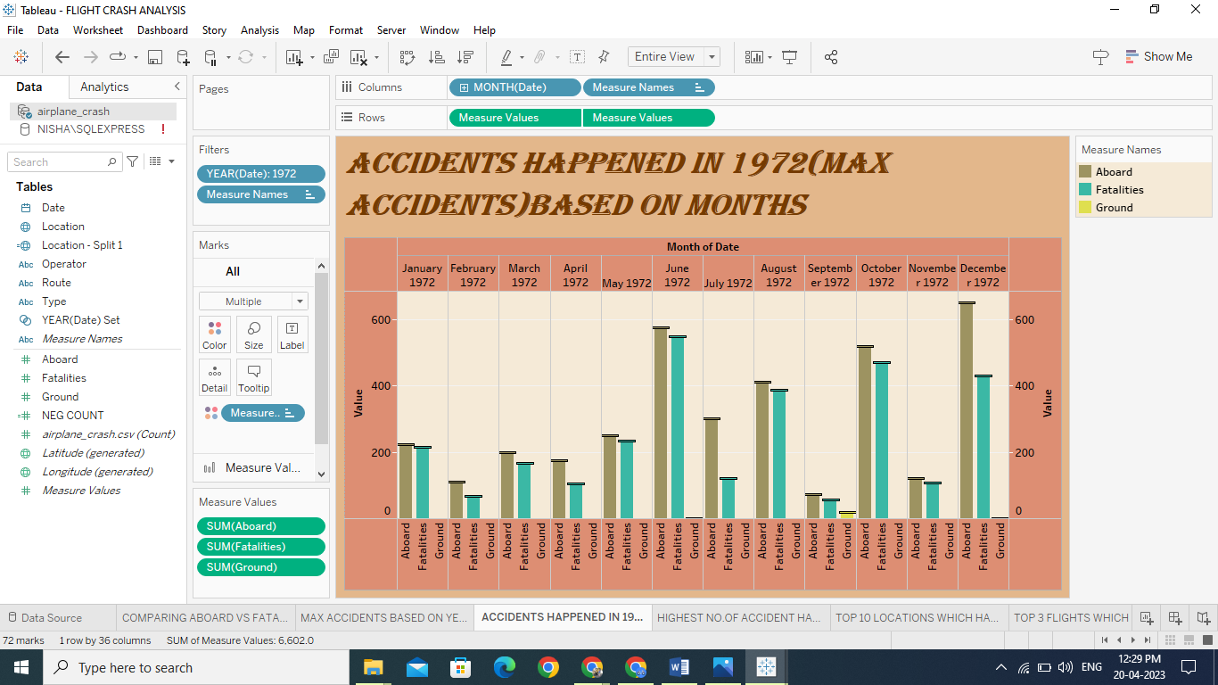

**3.5 HIGHEST NO.OF ACCIDENTS HAPPENED BY OPERATORS**

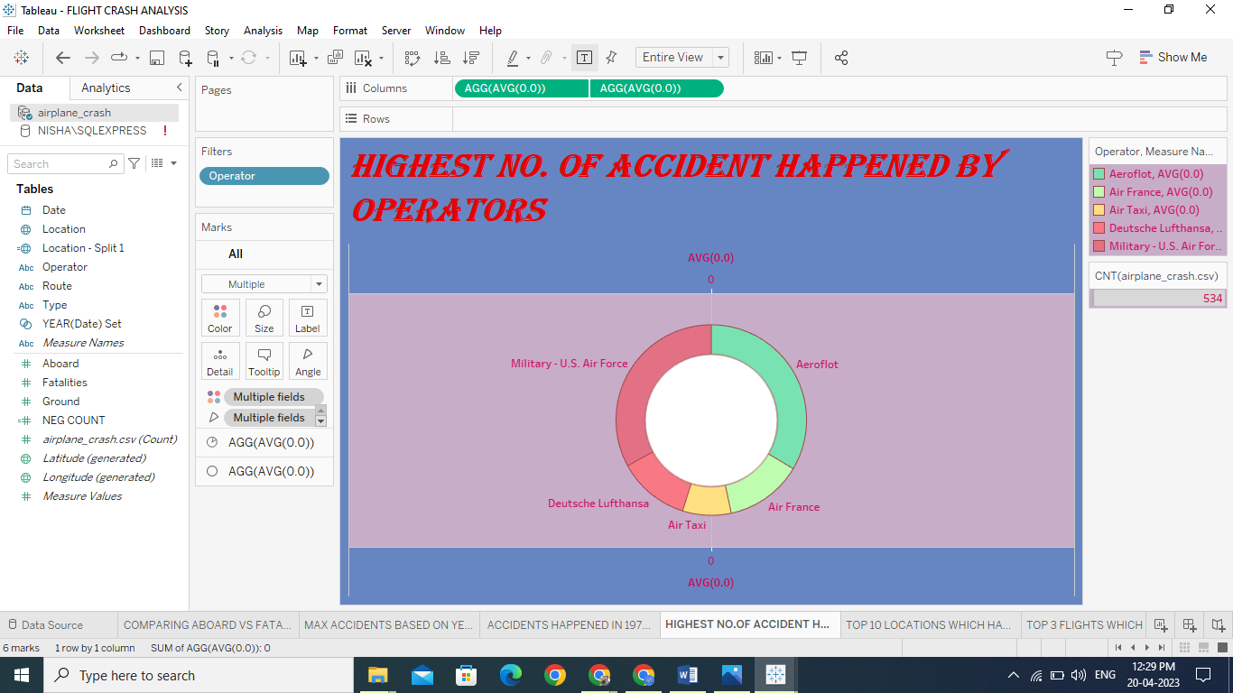

**3.6 TOP 10 LOCATIONS WHICH HAD MORE ACCIDENTS**

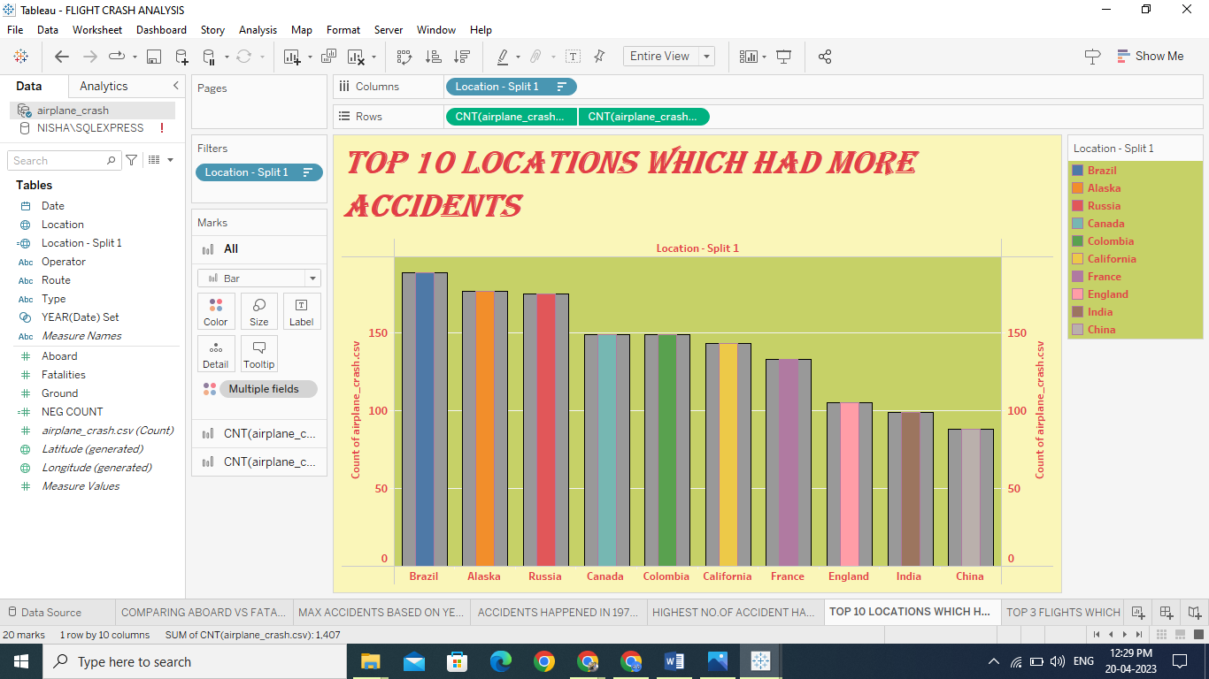

**3.7 TOP 3 FLIGHTS WHICH HAVE MAX ACCIDENT HISTORY**

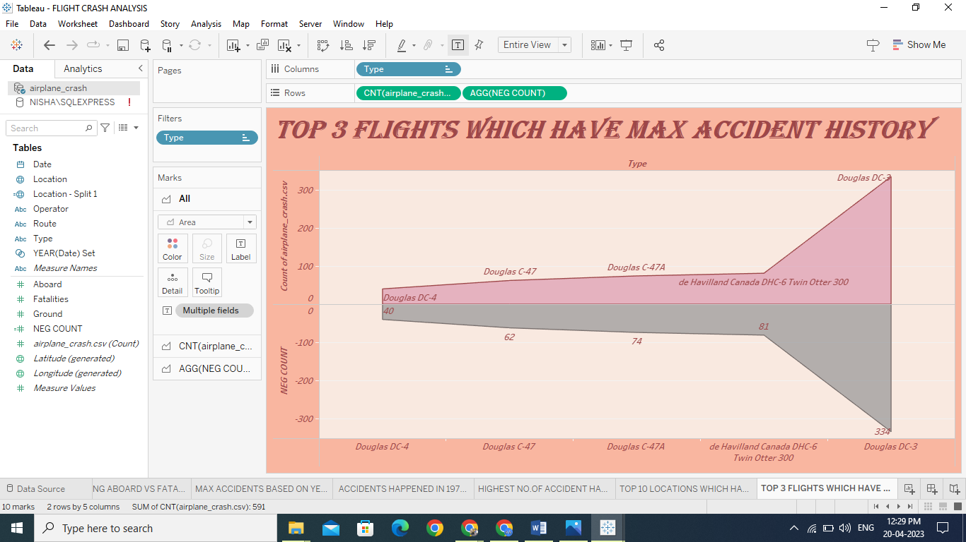

**3.8 ACCIDENTS BASED ON REGIONS**

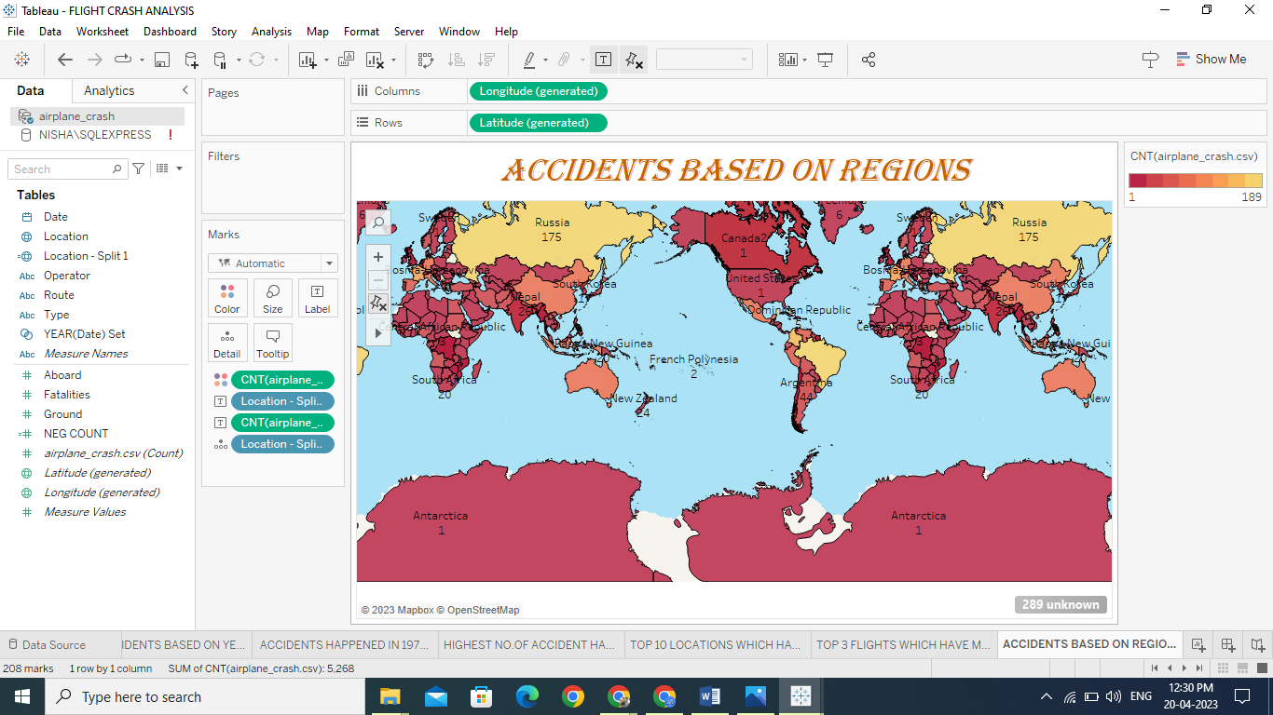

**DASHBOARD 1**

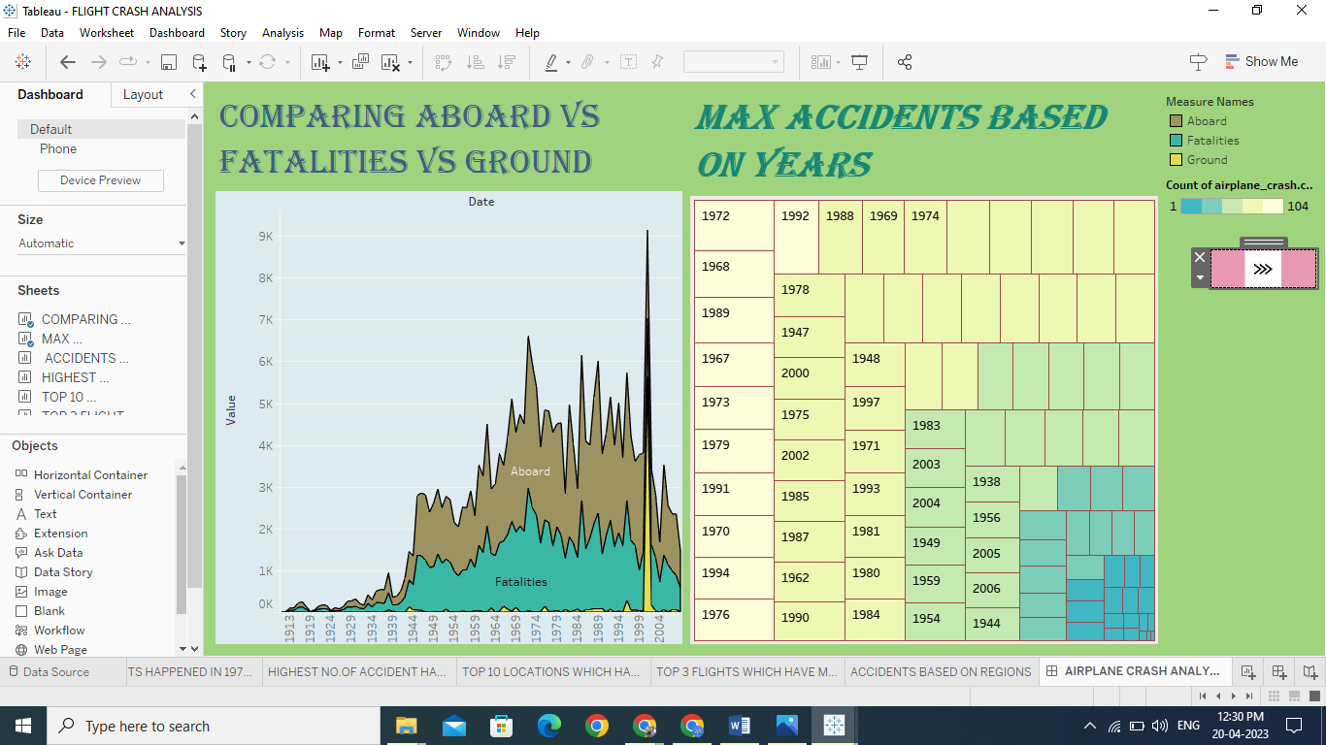

**DASHBOARD 2**

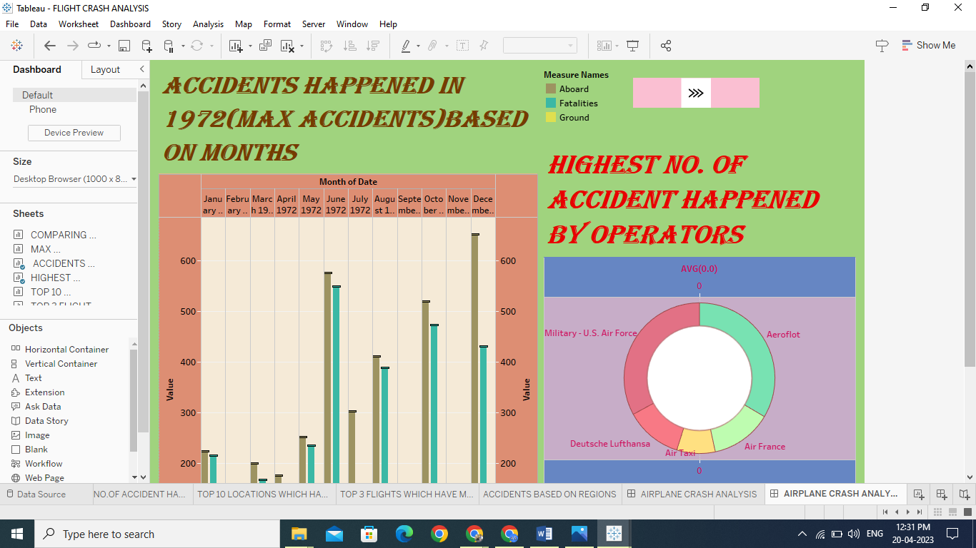

**DASHBOARD 3**

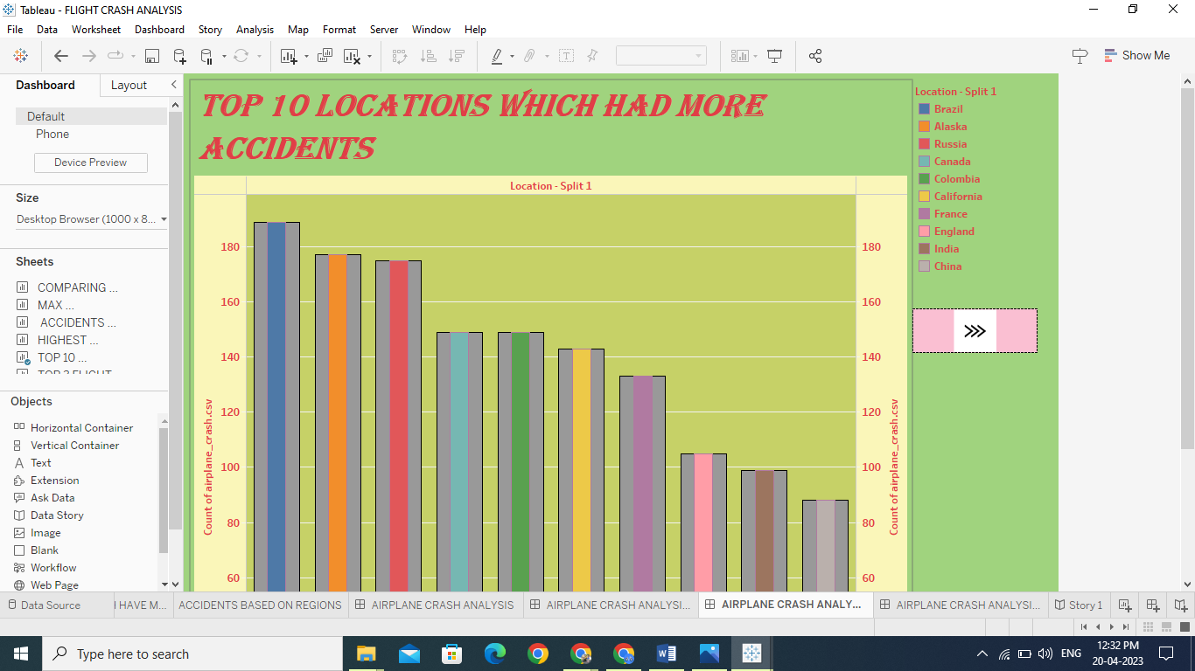

**DASHBOARD 4**

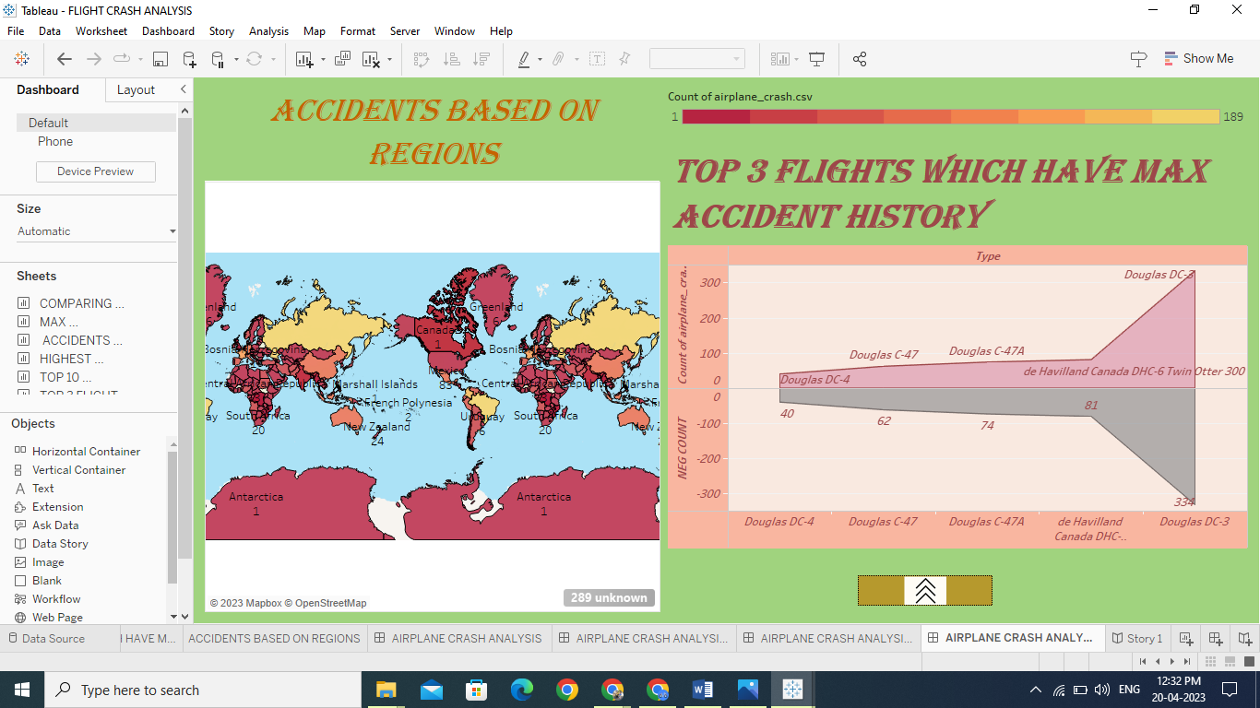

**STORY 1**

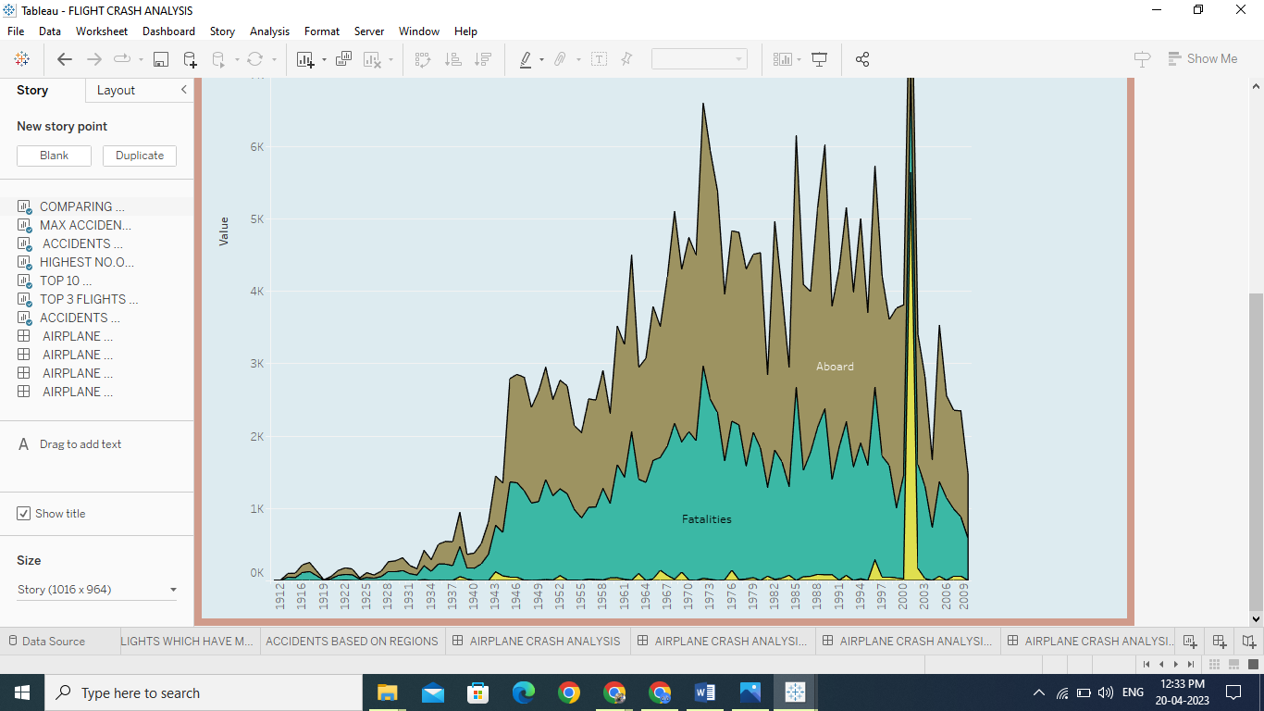

**STORY 2**

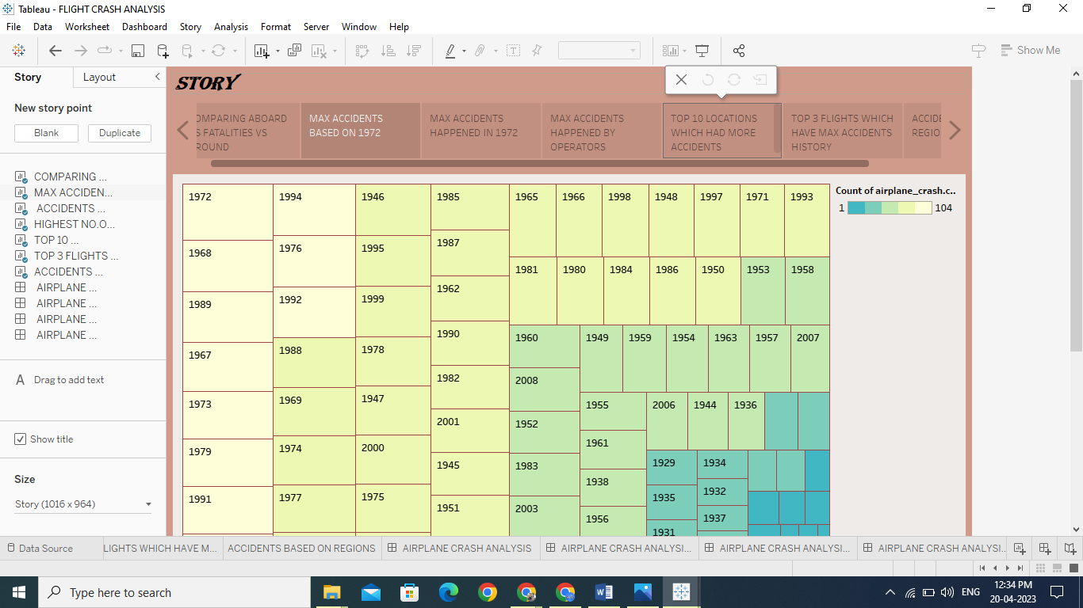

**STORY 3**

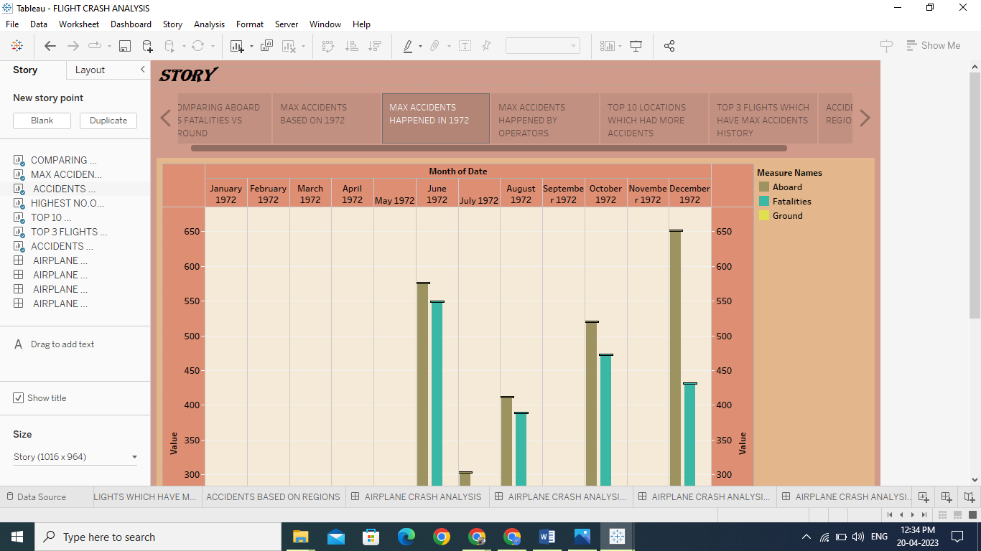

**STORY 4**

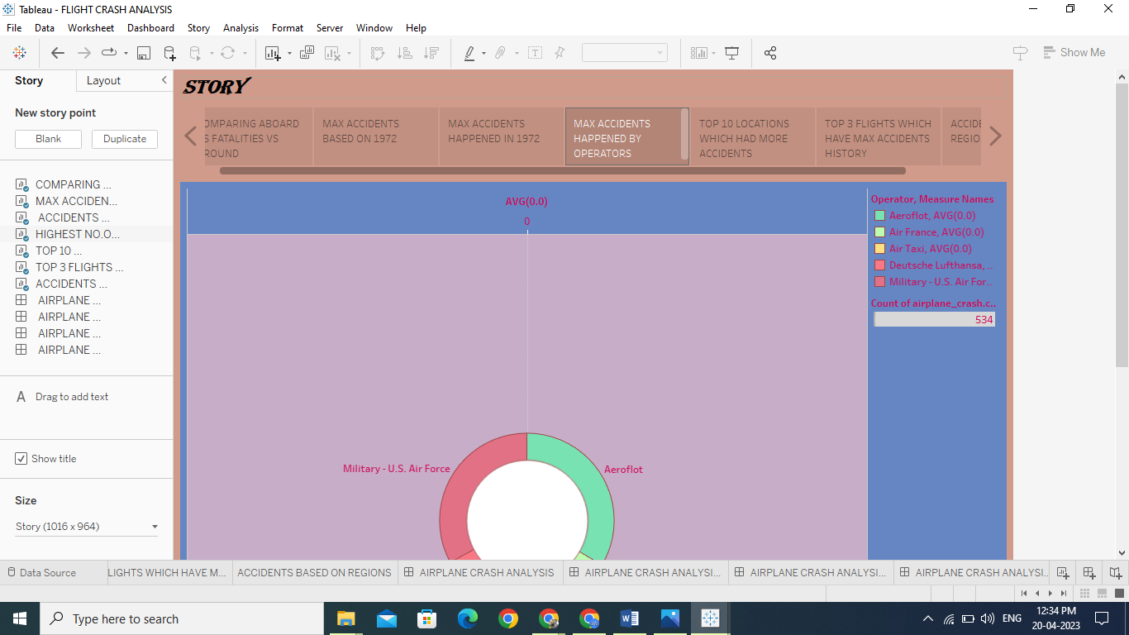

**STORY 5**

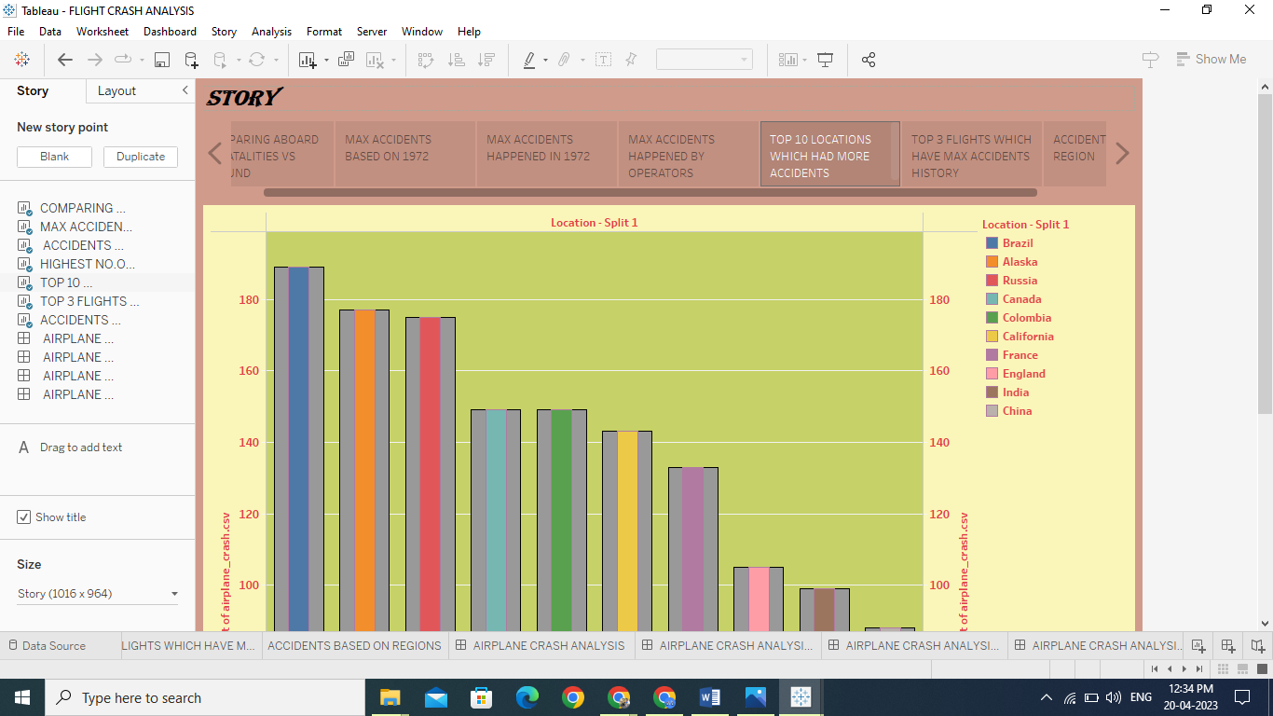

**STORY 6**

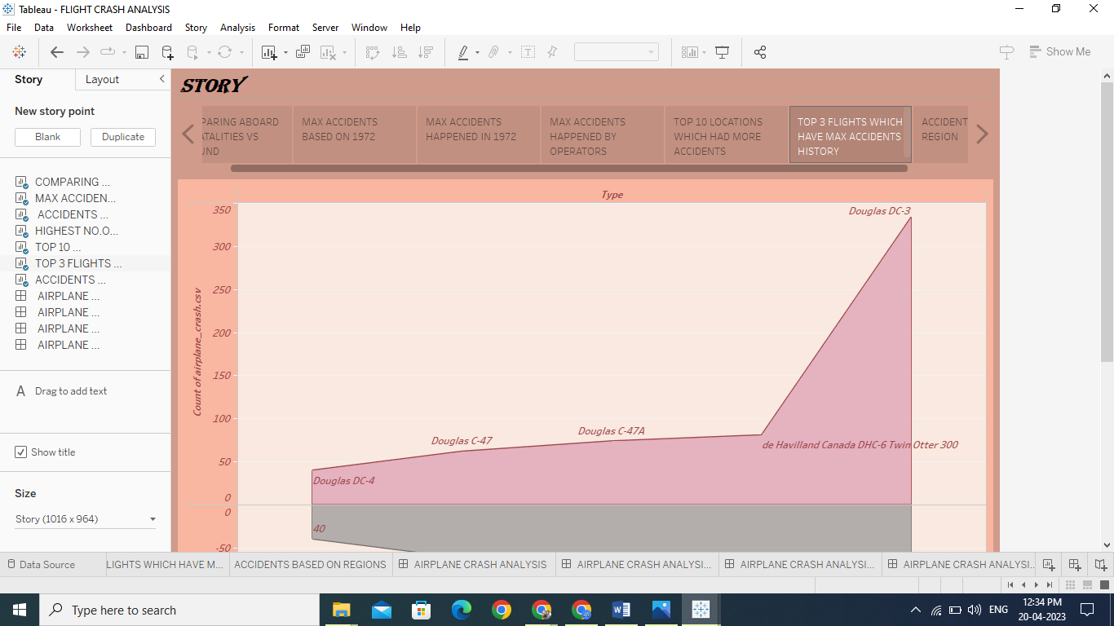

**STORY 7**

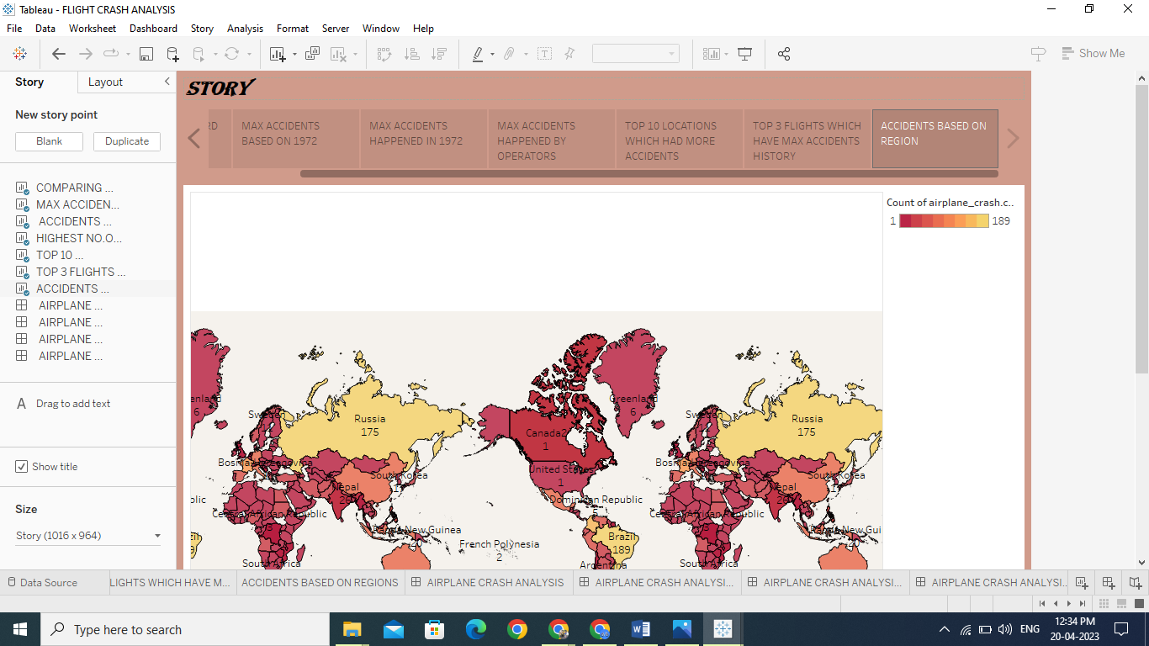

**ADVANTAGES AND DISADVANTAGES**

**4.1 DISADVANTAGES**

* Serious injuries to the crew members
* Damage to material
* Sometimes leads to disaster in a region.

**5 CONCLUSION**

The cause of this accident is the combination of several factors, ambiguously written procedures, inadequate training, unexpected operational situations or individual judgements. Situational awareness, environmental and crew coordination factors, as well as shortcomings in pilot technical knowledge, skills and experience, also can cause accidents. Other mistakes might be the result of improper airspace design or crew coordination.

As an initial event, the clear ice formed on the upper surface of the wings was not detected and de-iced well. The company instruction, procedures and even the equipment were not sufficient to remove the clear ice from the wing surface. Hence during the take-off the clear ice was broken off the wings and ingested by the engines and caused damage the engine fan stages, which led to engine surges and failure. The pilot had no sufficient knowledge and training to identify the problem and taking the necessary action. Further‐more, there was no knowledge for applying Automatic Thrust Restoration system (ATR) within the company (SAS). Therefore it was activated and increased the engine power without the pilot knowledge. Another contributing cause was poor emergency landing responses in terms of speed and flap position for approach and landing.

Finally, it may be concluded that unsafe pre-conditions which had been created by SAS organization in terms of training, instruction, operational procedures etc. were blamed for pilot and technicians errors and mistakes which led to the crash.

1. **FUTURE SCOPE (PREVENTION)**

Investigation is focused on determining and analysing the circumstances of the accident, flight proficiency of the aircrew, organization of the flight, status of the aviation equipment, medical status and professional competence of the aircrew as well.

Measure to prevent accident rate from increasing are developed by operators as a result of an analysis focused on activities and causes of them. Prevention should primarily focus on training and education of the aircrew, care for the aviation equipment, technical support to air traffic, organizational and control issues as well as the field of care for the labour force etc. However,

Prevention should prove inefficient if not carried out on a basis of planning and steadiness. As its substantial part is made up of the analyses of air accidents, the operator is liable to make constant use of all the technical tools of objective control mostly flight data recorders, magnetophone, tapes etc.

The tools must be held in perfect technical status and follow innovation in time. Some airlines may find it financially too demanding, but investments into prevention are not meant as money through out of the window. It can be said for sure that any air accident is much more expensive than the costs of the preventive measures.

Air accident is seldom a result of a single cause. It is typical for them to originate from a combination of factors. It is the cummulation of these events, which will eventually result in air accident. Thus, by prevention of accidents is meant timely detection and elimination of the causes before develops into an event.

1. **VIDEO LINK**

https://drive.google.com/file/d/1JQ391IIld4AUoV3E5WIRVk7cYjnOOfUc/view?usp=share_link